Chapter 7 Wireless and Mobile Networks
-------------------------------------------------------------------------
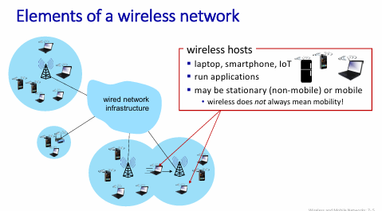
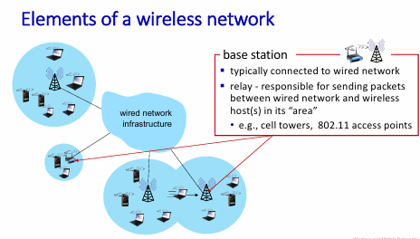
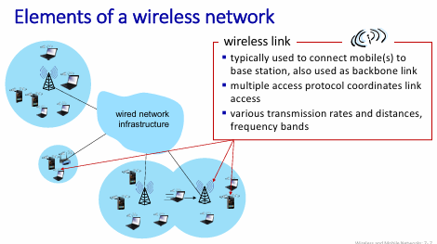
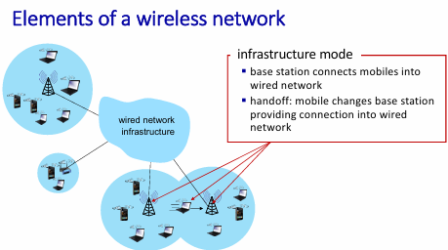
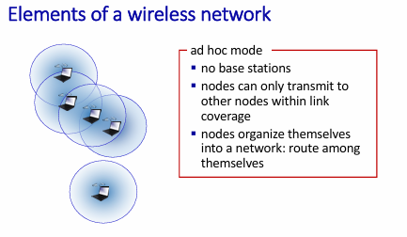
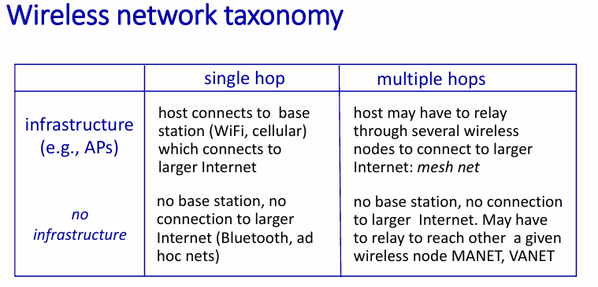

- Wireless

- Wireless Links and network characteristics

Wireless Link Characteristics
1. Fading (Attenuation)
Wireless radio signal attenuates (loses power) as it propagates.
Free Space Path Loss
- Free space path loss ∼ (f d)²

2. Multipath Propagation
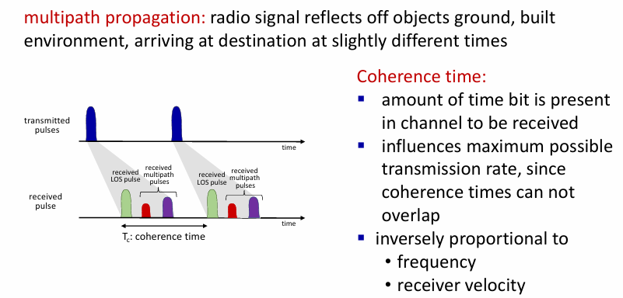

4. Wireless Link Characteristics: Noise
Noise Sources
- Interference from motors, appliances, and other sources using wireless frequencies.
SNR: Signal-to-Noise Ratio
- Larger SNR → easier to extract signal from noise (good).
SNR vs BER Tradeoff (Bit Error rate)
- Given a physical layer:
  - Increase power → increase SNR → decrease BER.
- SNR may change with mobility →
Dynamically adapt physical layer:
  - Modulation technique
  - Data rate

5. Hidden Terminal Problem
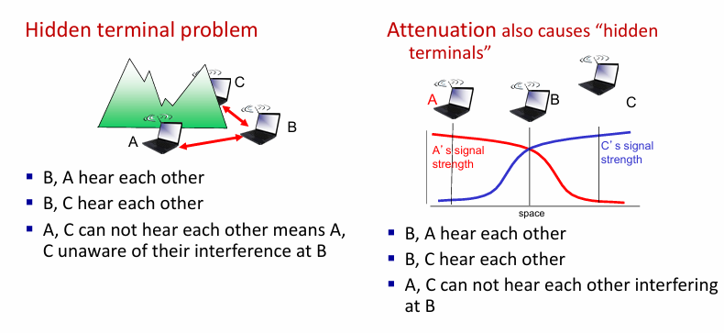
- CDMA: code division multiple access

1. Basic Concepts
- A unique “code” is assigned to each user → code set partitioning.
- All users share the same frequency, but each user has its own “chipping sequence” (code) to encode data.
- This allows multiple users to coexist and transmit simultaneously with minimal interference, if codes are orthogonal.

2. CDMA Encoding and Decoding
Encoding
- Operation: Inner product
- Formula:
Encoded data = (original data) × (chipping sequence)
Decoding
- Operation: Summed inner-product
- Formula:
Decoded data = Σ (encoded data × chipping sequence)
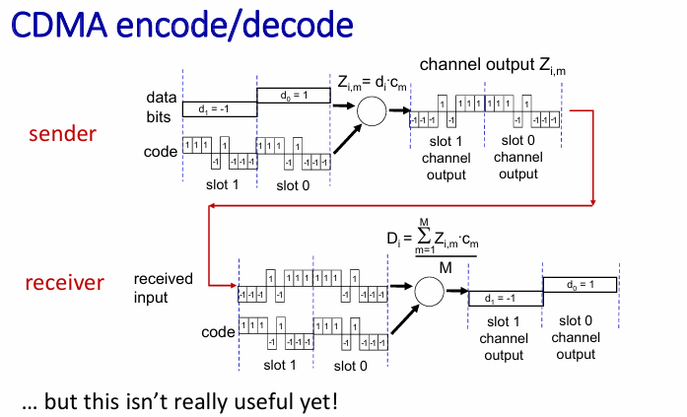

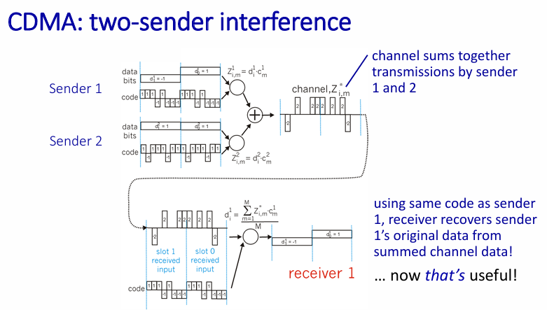

- WiFi: 802.11 wireless LANs
802.11 LAN Architecture
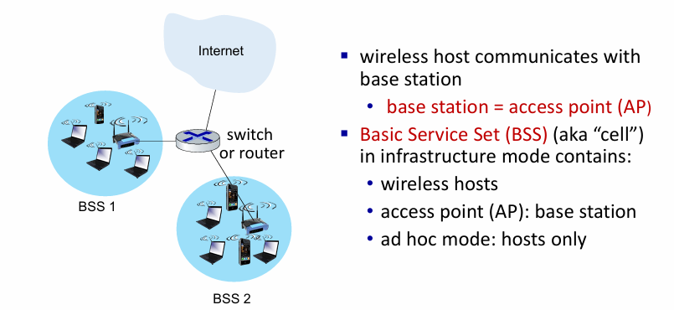

802.11: Channels
  - Spectrum is divided into channels at different frequencies.
  - AP administrator chooses channel for the AP.
  - Interference possible:
  - Neighboring AP may choose the same channel.

802.11: Association
Arriving host must associate with an AP
Steps:
- Host scans channels, listening for beacon frames containing:
  - AP’s name (SSID)
  - AP’s MAC address
- Host selects an AP to associate with.
- Host may perform authentication (Chapter 8).
- Host typically runs DHCP to get IP address in AP’s subnet.

802.11: Passive vs Active Scanning
1. Passive Scanning
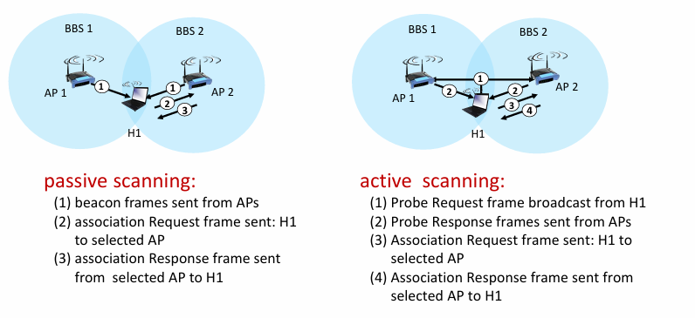

IEEE 802.11: Multiple Access
Goal: Avoid collisions
- Two or more nodes transmitting at the same time → collision.
Mechanism: CSMA (Carrier Sense Multiple Access)
- Sense channel before transmitting.
- Do not transmit if another transmission is detected.
Why no collision detection in 802.11?
- Hard to detect collisions because:
    - Transmitted signal is very strong.
    - Received signal is weak due to fading.
- Hidden terminal problem and fading prevent reliable collision detection.
Therefore: 802.11 uses CSMA/CA
- Collision Avoidance, not collision detection.

IEEE 802.11 MAC Protocol: CSMA/CA
Sender Behaviour
- If channel is idle for DIFS → transmit entire frame (no CD).
- If channel is busy, start random backoff timer:
  - Timer counts down only when the channel is idle.
  - Transmit when timer expires.
- If no ACK received:
  - Increase backoff interval.
  - Repeat step 2.
Receiver Behaviour
- If frame received OK:
  - Send ACK after SIFS.
  - ACK required due to hidden terminal problem.
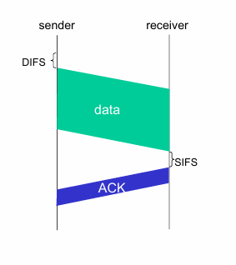

Avoiding Collisions (RTS–CTS Mechanism)
Idea
Sender reserves channel before sending data.
Procedure
- Sender sends RTS (Request to Send) using CSMA.
  - RTS packets may collide, but are short.
- AP (base station) sends CTS (Clear to Send).
- CTS heard by all nodes:
  - Sender transmits DATA.
  - Other stations defer transmissions
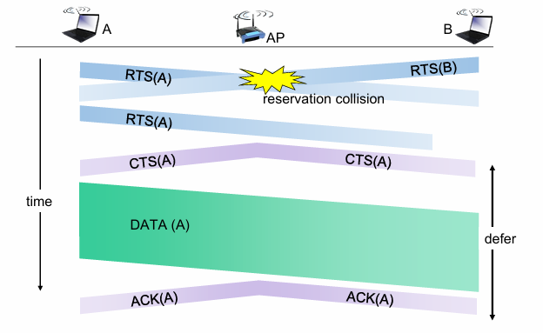.

802.11 Frame: Addressing
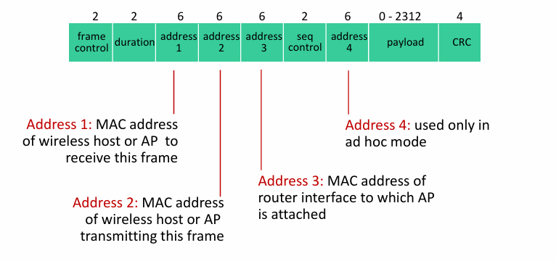

802.11: Mobility Within Same Subnet
- Host stays in same IP subnet → IP address stays same.
- Switch must determine which AP the host is currently associated with.
- Switch uses self-learning (Chapter 6):
  - Learns which switch port receives frames from H1.
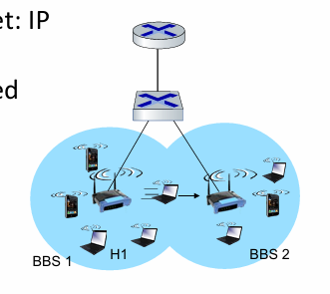

802.11: Advanced Capabilities
1. Rate Adaptation
- Base station and mobile dynamically adjust transmission rate.
- Rate depends on SNR. Signal-to-Noise Ratio
- Behavior:
- As node moves away from AP:
  - SNR decreases
  - BER increases
- When BER becomes too high:
  - Switch to lower transmission rate
  - Lower rate → lower BER Bit Error Rate

2. Power Management
- Node tells AP: “I am going to sleep until next beacon frame.”
  - AP will not send frames to the sleeping node.
- Node wakes before next beacon frame.
- Beacon frame contains list of mobiles with AP-to-mobile frames waiting.
  - If frames are waiting → node stays awake.
  - Otherwise → node sleeps again until next beacon.

- Bluetooth
Personal Area Networks: Bluetooth

Basic Characteristics
- Coverage: Less than 10 m diameter
- Purpose: Replacement for cable
- Ad hoc network: no infrastructure
- Operating band: 2.4–2.5 GHz ISM band
- Data rate: Up to 3 Mbps

Master–Client Architecture
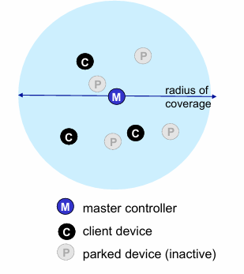

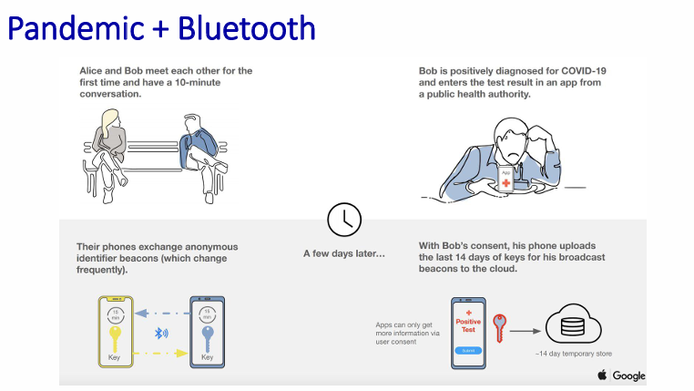

- Cellular networks: 4G and 5G

4G / 5G Cellular Networks — Complete Structured Notes

1. Overview
- 4G/5G is the solution for wide-area mobile Internet.
- Widespread deployment:
- More mobile-broadband devices than fixed broadband (5:1 in 2019).
- 4G availability: 97% in Korea, 90% in the US.
- Transmission rates: up to hundreds of Mbps.
- Technical standards by 3GPP (3rd Generation Partnership Project)
- 4G standard: LTE (Long-Term Evolution)

2. 4G/5G: Similarities vs Differences with Wired Internet
Similarities
- Edge/core distinction (both operated by same carrier).
- Global cellular network = a network of networks.
- Uses familiar protocols:
  - HTTP, DNS, TCP, UDP, IP, NAT
  - Data/control plane separation
  - SDN
  - Ethernet
  - Tunneling
- Interconnected with wired Internet.
Differences
- Wireless link layer is different.
- Mobility is a first-class service.
- User identity via SIM card.
- Subscription-based business model:
  - Strong notion of home network and visited/roaming networks.
  - Global access with authentication infrastructure and inter-carrier settlements.

3. Elements of 4G LTE Architecture
3.1 User Equipment (UE)
- Smartphones, tablets, laptops, IoT devices with LTE radio.
- Has 64-bit IMSI (International Mobile Subscriber Identity) stored on SIM card.

3.2 Base Station (eNode-B)
- At the edge of the carrier’s network.
- Manages radio resources and connected mobile devices.
- Coordinates authentication with MME and HSS.
- Compared with WiFi AP:
  - Plays active role in user mobility.
  - Coordinates with nearby base stations to optimize radio use.

3.3 Radio Access Network (4G Radio)
- Connects UE to eNode-B.
- Many possible frequency bands:
  - Popular bands: 600, 700, 850, 1500, 1700, 1900, 2100, 2600, 3500 MHz
- Separate uplink and downlink channels.
- Channel sharing among users:
  - OFDM (Orthogonal Frequency Division Multiplexing)
→ combination of FDM + TDM.
- Up to hundreds of Mbps per device.

3.4 Home Subscriber Service (HSS)
- Stores information for devices whose home network this is.
- Works with MME for authentication.

3.5 Serving Gateway (S-GW) & PDN Gateway (P-GW)
Serving Gateway (S-GW)
- Routes traffic between eNode-B and P-GW.
- Supports mobility with extensive tunneling.
PDN Gateway (P-GW)
- Gateway to the mobile cellular network.
- Appears like a regular Internet gateway router.
- Provides NAT services.

3.6 Mobility Management Entity (MME)
- Handles device authentication (device-to-network & network-to-device) with HSS.
- Mobile device management:
  - Handover between cells.
  - Tracking device location.
  - Paging device.
- Sets up tunneling path from UE to P-GW.

- 4G LTE: Data Plane & Control Plane Separation
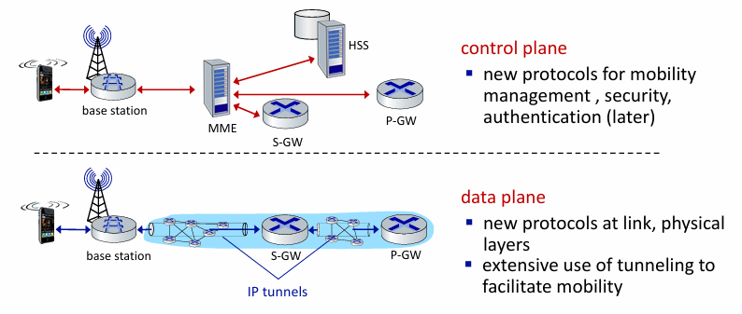

5. LTE Data Plane Protocol Stack
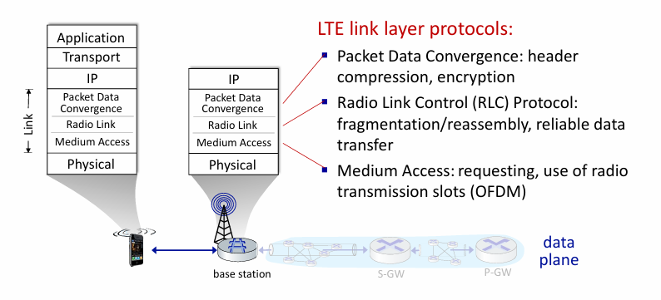
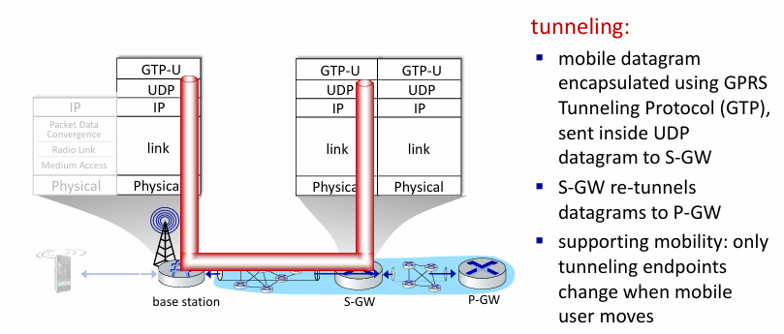
6. LTE Data Plane: Association with a Base Station
- BS broadcasts primary sync signal every 5 ms on all frequencies.
  - Multiple carriers may broadcast sync signals.
- Mobile detects:
  - Primary sync signal
  - Secondary sync signal
  - BS information (bandwidth, configuration, carrier info)
- Mobile may detect multiple base stations/networks.
- Mobile selects BS to associate with (prefers home carrier).
- Further authentication, state establishment, data-plane setup occurs.

7. LTE Mobile Sleep Modes
- Light sleep: after hundreds of milliseconds of no activity.
- Wakes periodically to check for downstream data.
- Deep sleep: after 5–10 seconds of inactivity.
- UE may change cells while sleeping → must re-establish association.

8. Global Cellular Network: A Network of IP Networks
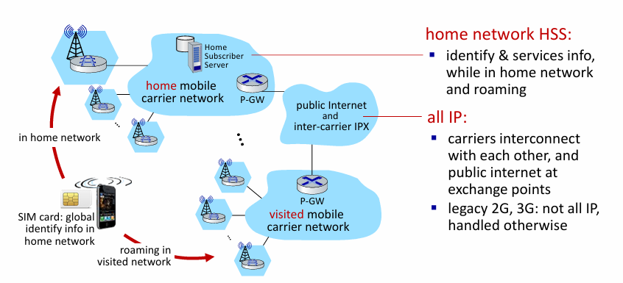

- Mobility

- Mobility management: principles

Mobility — Complete Notes

1. What is Mobility?
Mobility refers to how a device moves across networks from the network's perspective.
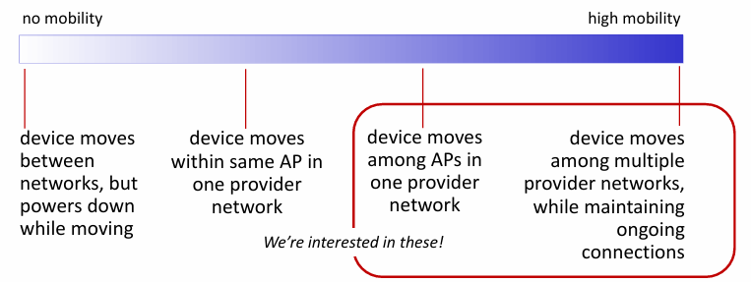

2. Mobility Challenge
When a device moves from one network to another:How will the network know where to forward packets?

3. Mobility Approaches
Approach 1: Let the Network (Routers) Handle Mobility
- Routers advertise the well-known name/address (e.g., permanent IP address or location number) of visiting mobile nodes.
- Achieved through routing table exchanges.
- Internet routing can do this already using longest prefix match.
Problem
❌ Not scalable to billions of mobile devices.

Approach 2: Let End-Systems Handle Mobility (Edge Functionality)
Two Methods
- Indirect Routing
  - Correspondent → Home network → Mobile
  - Home network forwards packets to mobile’s current location.
- Direct Routing
  - Correspondent learns mobile’s foreign address.
  - Correspondent sends datagrams directly to mobile.

4. Contacting a Mobile Friend (Analogy)
If a friend frequently changes location, how do you find them?
Options:
- Search all phone books?
- Expect them to notify you?
- Call their parents?
- Facebook! → A definitive “home” where you can find their current location.
Importance of a “Home”
- A place that always knows where you are.

5. Home Network & Visited Network — 4G/5G
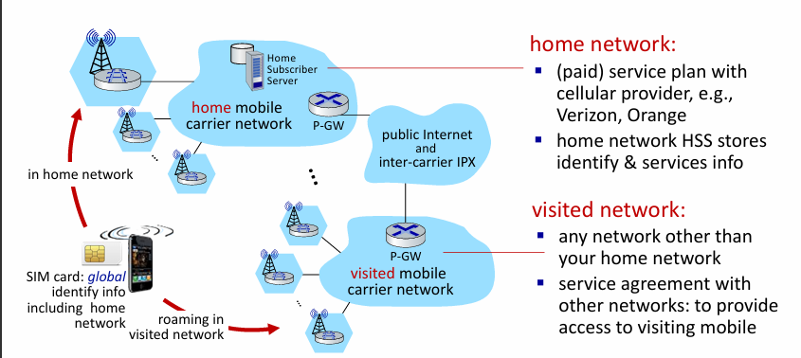

6. Home Network & Visited Network — ISP/WiFi
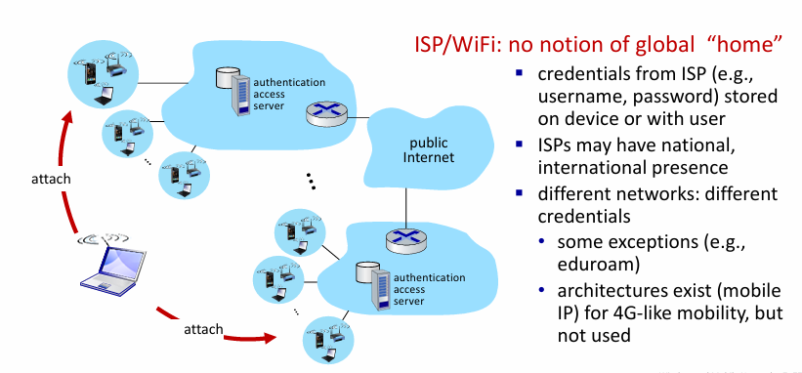

7. Home & Visited Networks — Generic Model
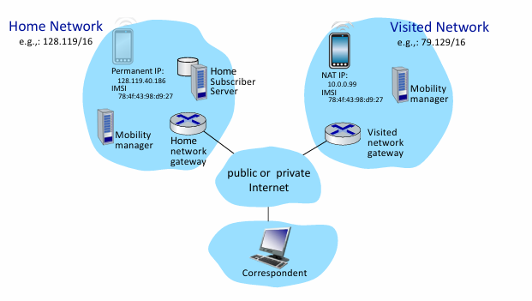

8. Registration Process
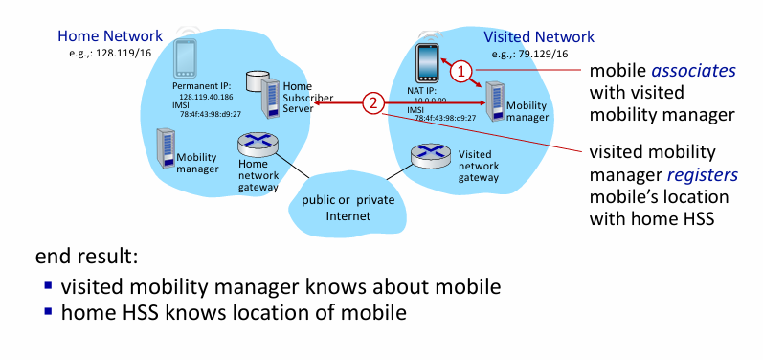

9. Mobility with Indirect Routing
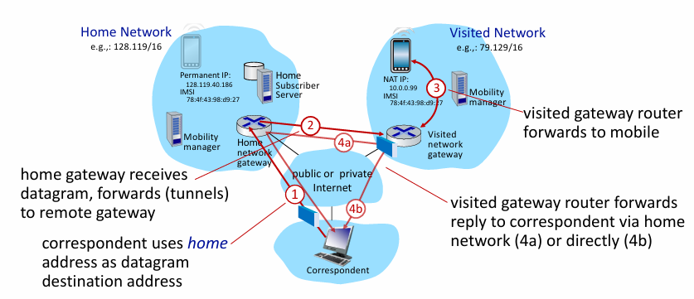

Indirect Routing: Comments
Triangle Routing Problem
- Inefficient when correspondent & mobile are in the same network.
Mobility Support
- Mobile moves among visited networks transparently:
  - Registers in new visited network
  - New visited network registers with home HSS
  - Home network continues forwarding datagrams
  - Ongoing connections (e.g., TCP) do not break

10. Mobility with Direct Routing
Process
- Correspondent contacts home HSS
- Home HSS provides mobile’s current visited network
- Correspondent addresses datagrams to that visited network
- Visited gateway forwards to mobile
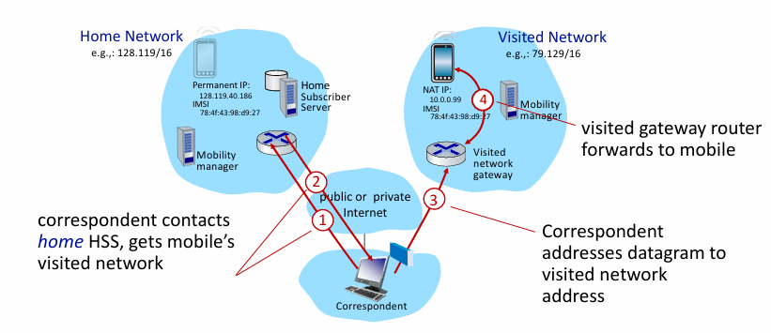

Direct Routing: Comments
- Benefits
  - Fixes triangle routing inefficiency.
- Downsides
  - Not transparent to correspondent:
  - Correspondent must obtain care-of address.
  - If mobile changes network:
  - Additional complexity required.

- Mobility management: practice
  - 4G/5G networks
  - Mobile IP
- Mobility: impact on higher-layer protocols

Mobility in 4G Networks — Major Mobility Tasks
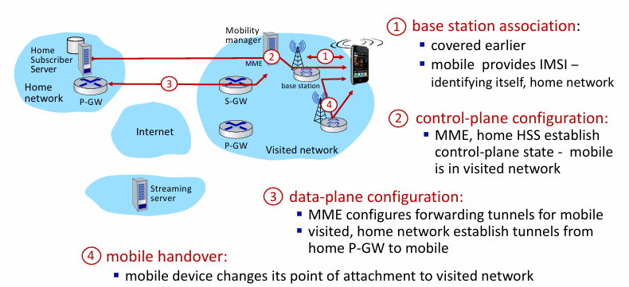

Configuring LTE Control-Plane Elements
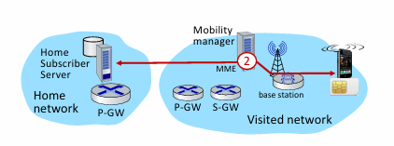
Steps
- Mobile communicates with local MME via base-station control-channel.
- MME uses mobile’s IMSI to contact home HSS:
  - Retrieve authentication, encryption, network service information.
  - Home HSS learns mobile is now in visited network.
- Base station & mobile select radio-channel parameters for data-plane communication.

Configuring Data-Plane Tunnels for Mobile
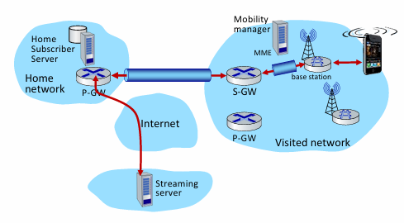
- S-GW ↔ Base Station Tunnel
- When mobile changes base stations:
  - Only change endpoint IP address of the tunnel.
- S-GW ↔ Home P-GW Tunnel
- Implements indirect routing.
- Heavy use of GTP (GPRS Tunneling Protocol):
  - Mobile’s datagram → encapsulated in GTP → UDP → IP.

Handover Between Base Stations (Same Provider Network)
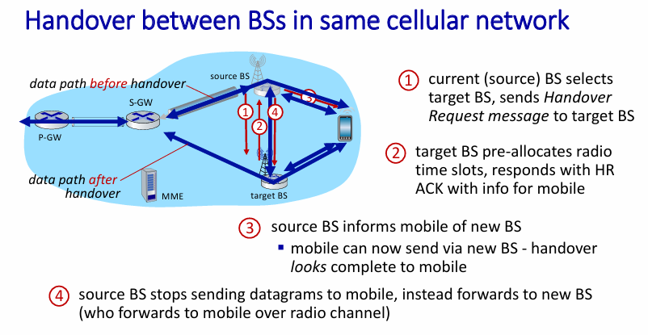
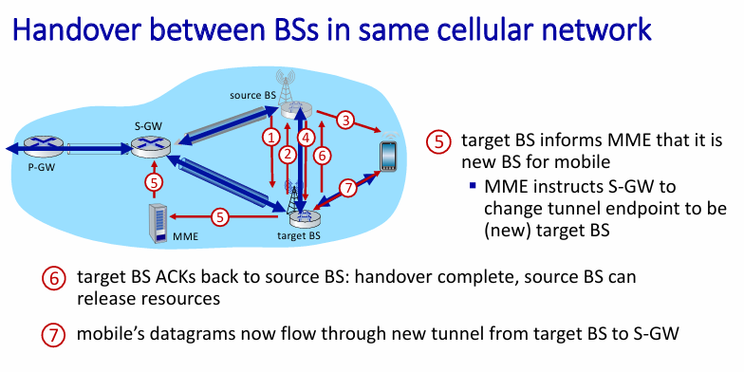
Mobile IP
- Standardized ~20 years ago (RFC 5944), but never widely deployed.
- At that time, WiFi + 2G/3G was “good enough,” so full Mobile IP wasn’t needed.
- Uses indirect routing via tunneling through the home network.
- Uses ICMP-based protocols for:
  - discovering foreign agents
  - registering new location with home agent

Wireless/Mobility → Impact on Higher Layers
- In theory: higher layers (TCP/UDP) should work normally because the service model is the same.
- In practice: performance suffers due to:
  - wireless bit errors
  - link-layer retransmissions
  - handover losses
- TCP wrongly interprets wireless losses as congestion → reduces window unnecessarily.
- Real-time traffic (voice/video) suffers from added delay.
- Wireless bandwidth is limited → makes impairments worse.

